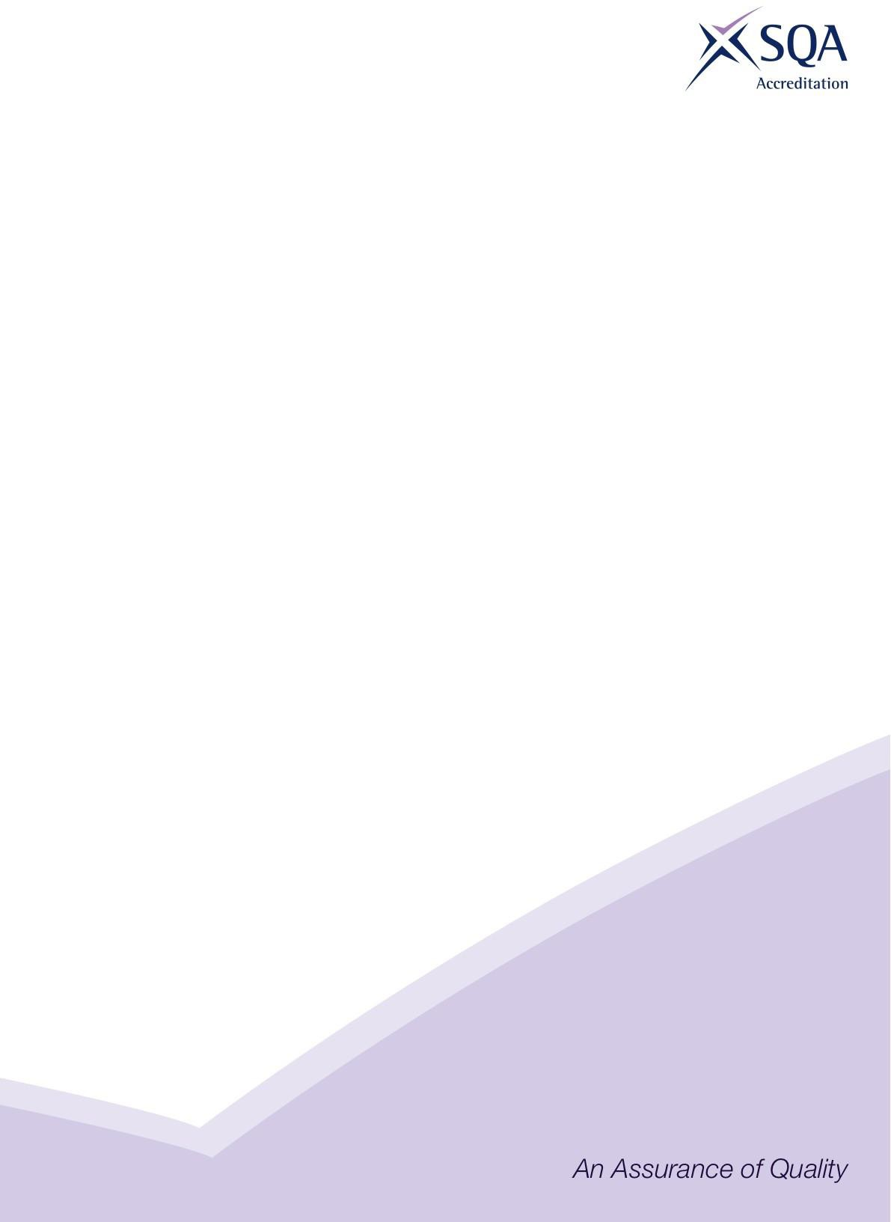
Quarterly Statistics Report
Highlights for Quarter 3 2024–25:
1 October – 31 December 2024

Publication date: March 2025
Revised: April 2025

Published by the Scottish Qualifications Authority (SQA) Accreditation
The Optima Building, 58 Robertson Street, Glasgow, G2 8DQ
Lowden, 24 Wester Shawfair, Dalkeith, Midlothian EH22 1FD

https://accreditation.sqa.org.uk

The information in this publication may be reproduced in support of SQA qualifications. If it is reproduced, SQA should be clearly acknowledged as the source. If it is to be used for any other purpose, then written permission must be obtained from SQA. It must not be reproduced for trade or commercial purposes.

© Scottish Qualifications Authority 2025

Contents
Summary 1
Data submissions 1
1 Introduction 3
Methodology 3
2 Accredited qualifications 5
2.1 Total candidate registrations and certifications 6
2.2 Top 5 qualifications 6
2.3 Registrations and certifications by qualification type 7
2.3.1 SVQs 7
2.3.2 Non-SVQs 8
2.4 Analysis by awarding body 9
2.4.1 SVQs 9
2.4.2 Non-SVQs 10
2.5 Analysis by developer 10
2.5.1 SVQs 10
2.5.2 Non-SVQ 11
2.6 Analysis by qualification categories 12
3 Workplace Core Skills 13

Summary
This report provides statistical information on SQA Accreditation approved qualifications for the third quarter (Q3) of 2024–25 (1 October–31 December 2024). This data is submitted by awarding bodies, who are responsible for quality assuring their data submissions.
Since the first quarter of 2024–25 there was a change in how the number of qualifications is reported. The number of qualifications here indicates the number of qualifications received via data returns; this may include late certifications (qualifications past their certification end date, for which the awarding body has indicated there is a certification). Previously only the number of currently live qualifications were reported (qualifications which have not yet reached their accreditation end date).
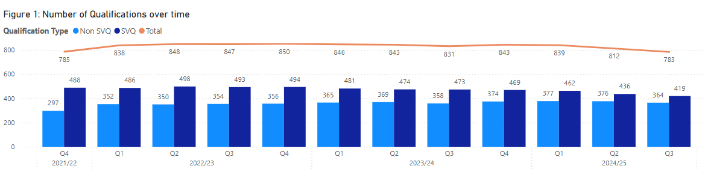
At the end of this period there were 783 accredited qualifications: 419 Scottish Vocational Qualifications (SVQs), and 364 Non-SVQs. In Q3 2023–24 there were 831 accredited qualifications, compared to 847 in Q3 of 2022–23.

Data submissions
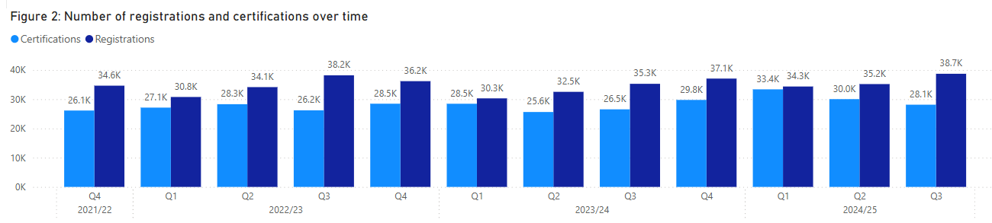
There were a total of 38,703 registrations (a 10% increase from Q2 2024–25) and 28,129 certifications (an 6.33% decrease compared to Q2 2024–25) in Q3. (These totals do not include Workplace Core Skills.)

SVQs
Of these totals, 11,910 (31.59%) were SVQ registrations and 6,803 (24.77%) were SVQ certifications. SQA was the awarding body that had the highest percentage of SVQ registrations (75.04%) and certifications (76.99%). The developer Skills for Care and Development accounts for the largest proportion of SVQ registrations and certifications — 29.21% and 37.59%, respectively.

Non-SVQ qualifications
There were 26,793 registrations and 21,326 certifications, an increase of 7.3% and a decrease of 0.03% respectively compared to Q2. First Aid Awarding (FAA) accounted for the highest number of Non-SVQ registrations and certifications: 33.8% of registrations, 41.71% of certifications. The developer First Aid Awarding Organisation Forum (FAAOF) has the highest number of registrations (35.36%) and certifications (42.74%).

Qualification category
The area with the highest number of registrations and certifications for SVQs is 003 Health Care, Social Care and Childcare.

Workplace Core Skills
There were a total of 9,754 registrations (an increase of 40.1% compared to Q2) and 6,475 certifications (a decrease of 0.48% compared to Q2).

1 Introduction
SQA Accreditation is the national accrediting body for Scotland with a statutory remit under the Education (Scotland) Act 1996 to accredit and quality assure qualifications in Scotland. Although part of the Scottish Qualifications Authority, SQA Accreditation is distinct and autonomous from SQA’s awarding function.
SQA Accreditation sets and specifies the requirements for accrediting qualifications to safeguard and support the interests of learners, parents, funding bodies, employers, providers and Scottish Government. We do this to promote and maintain public confidence in accredited qualifications and approved awarding bodies.

Methodology
This report summarises the qualification data that has been provided to us by approved awarding bodies, referred to as ‘data submissions’. Awarding bodies use a data submission template so all submissions are standardised. Registration and certification data is provided directly to SQA Accreditation (further information on the methodology can be found in our Methodology document).
The information in this report covers SQA accredited qualifications during the third quarter (Q3) of 2024–25 (1 October – 31 December 2024) and shows the number of candidates who were:
- registered for an SQA accredited qualification
- certificated for an SQA accredited qualification
The data has been analysed in relation to:
- qualification type
- awarding body
- developer
- qualification category (classification)
- Workplace Core Skills
This document is published alongside the raw data received from the awarding bodies. If there are any figures below 10, these are removed to protect confidentiality and are represented by an asterisk (*). The numbers given do not necessarily represent the number of learners, as a learner could register for several qualifications and could have achieved several certifications. The statistical information in this report is only collated by SQA Accreditation.
For upcoming data submissions, the following deadline dates apply and must be adhered to by all awarding bodies to ensure consistency and accuracy of data in future reports. The guidance document can be used to clarify how data must be submitted.

Table 1: Data submission deadlines for awarding bodies
Quarter | Submission deadline
Quarter 4 (1 January – 31 March 2025) | 14 April 2025
Quarter 1 (1 April – 30 June 2025) | 15 July 2025
Quarter 2 (1 July – 30 September 2025) | 15 October 2025
Quarter 3 (1 October – 31 December 2025) | 16 January 2026

2 Accredited qualifications
At the end of Q3 of 2024–25 there were 783 accredited qualifications*.
- 419 SVQs (53.51%)
- 364 Non-SVQs (46.49%)
*Note that this total does include qualifications that are within their lapsing period.
Compared to Q2 2024–25, the total number of qualifications submitted via data returns has decreased by 29. In Q3 2023–24 there were 831 qualifications submitted.
The number of qualifications has remained steady overall. The number of SVQs has decreased by 69 in the last three years, while Non-SVQs have increased by 67, indicating that awarding bodies are picking up more Non-SVQs and fewer SVQs.

2.1 Total candidate registrations and certifications
38,703 candidates were registered for SQA accredited qualifications in Q3. This is an increase of 10% compared to Q2 2024–25.
28,129 certificates were awarded for SQA accredited qualifications in Q3. This is a decrease of 6.33% compared to Q2 2024–25.

2.2 Top 5 qualifications
Table 2: Top 5 qualifications by registration
Qualification title | Registrations | Awarding body
Award in Emergency First Aid at Work at SCQF Level 6 | 6061 | First Aid Awards Limited (FAA)
NEBOSH National General Certificate in Occupational Health and Safety | 3077 | NEBOSH
SVQ in Social Services and Healthcare at SCQF level 6 | 1210 | SQA
SVQ in Social Services (Children and Young People) at SCQF level 7 | 914 | SQA
Highfield Award in Emergency First Aid at Work at SCQF Level 6 | 899 | Highfield Qualifications
Total | 12161

The Award in Emergency First Aid at Work at SCQF Level 6 (FAA) had the highest number of registrations in Q3 of 2024–25. These top 5 qualifications account for 32.25% of all registrations in Q3.

Table 3: Top 5 qualifications by certification
Qualification title | Certifications | Awarding body
Award in Emergency First Aid at Work at SCQF Level 6 | 5911 | First Aid Awards Limited
NEBOSH National General Certificate in Occupational Health and Safety | 2141 | NEBOSH
Highfield Award in Emergency First Aid at Work at SCQF Level 6 | 896 | Highfield Qualifications
SVQ in Social Services and Healthcare at SCQF Level 6 | 870 | SQA
Award in First Aid for Mental Health at SCQF Level 5 | 841 | First Aid Awards Limited
Total | 10,659

The Award in Emergency First Aid at Work at SCQF Level 6 (FAA) had the highest number of certifications in Q3 of 2024–25. These top 5 qualifications account for 38.81% of all certifications in Q3.

2.3 Registrations and certifications by qualification type
The following figures detail the number of registrations and certifications over a three-year period, broken down by qualification type. As there are peaks and troughs throughout the year for SVQs, it is more appropriate to compare the number of registrations and certifications to the equivalent quarter from the previous year than to the preceding quarter. As evidenced in the graphs below, the number of registrations and certifications for Non-SVQs has steadily risen over time, and is much higher than that of SVQs, despite there being more SVQs.

2.3.1 SVQs
- 11,910 registrations
- 6803 certifications
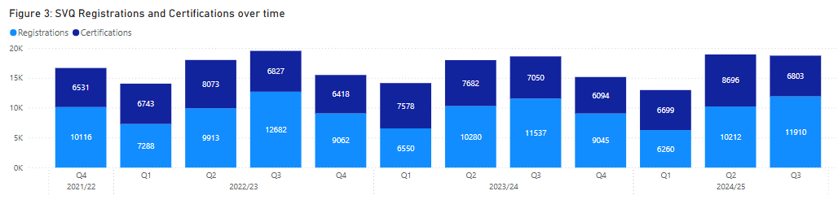
In comparison to Q3 of 2023–24:
- The number of SVQ registrations has increased by 3.23%.
- The number of SVQ certifications has decreased by 3.50%.

2.3.2 Non-SVQs
- 26,793 registrations
- 21,326 certifications

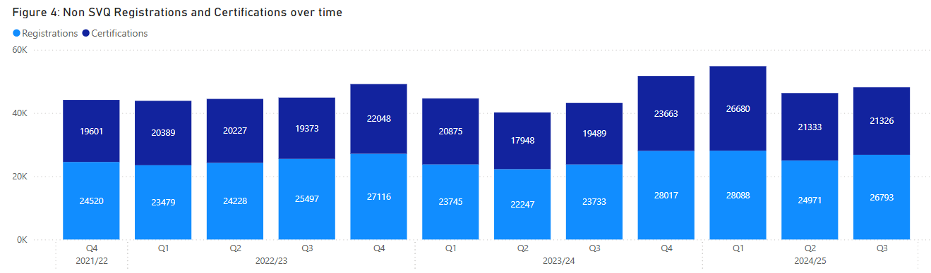
In comparison to Q3 of 2023–24:
- Non-SVQ registrations are 12.89% higher in Q3 2024–25.
- Non-SVQ certifications are 9.43% higher in Q3 2024–25.

2.4 Analysis by awarding body
At the end of the second quarter, there were 36 awarding bodies approved by SQA Accreditation. The number of qualifications offered by each awarding body varies greatly. The five largest awarding bodies, in terms of qualifications offered (including lapsed), are shown in table 4.
Table 4: Top 5 awarding bodies by qualifications
Awarding body | Qualifications
SQA | 344
RSL Awards Ltd | 58
Institute of the Motor Industry | 57
National Examination Board in Occupational Safety and Health | 34
GQA Qualifications Ltd | 26
Total | 519

2.4.1 SVQs
SQA continues to have the highest number of SVQ registrations and certifications:
- 75.04% of SVQ registrations
- 76.99% of SVQ certifications
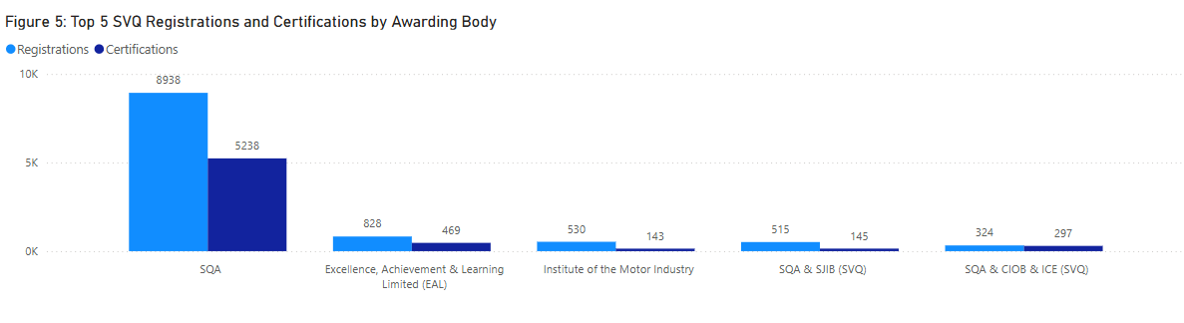

2.4.2 Non-SVQs
First Aid Awarding (FAA) accounted for the highest number of Non-SVQ registrations and certifications:
- 33.8% of registrations
- 41.71% of certifications

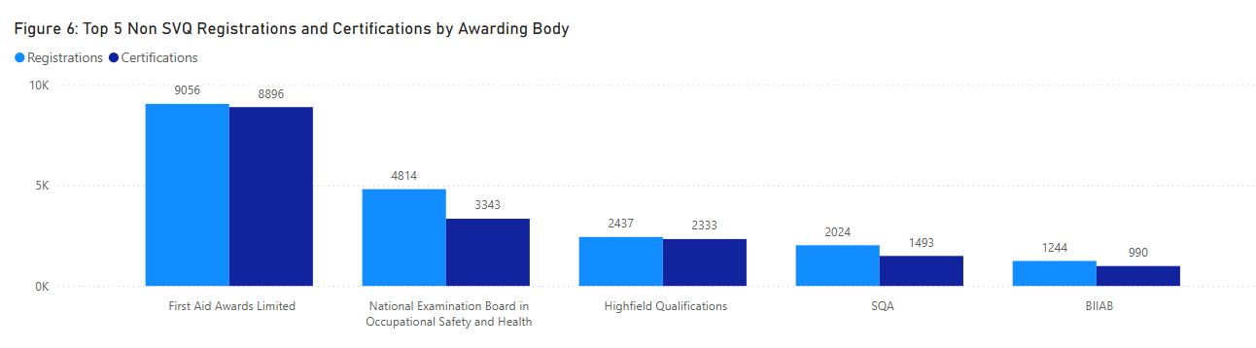

2.5 Analysis by developer
This section compares the registrations and certifications by developer across the two qualification types — SVQs and Non-SVQs. The following graph summarises the top registrations and certifications by developer.
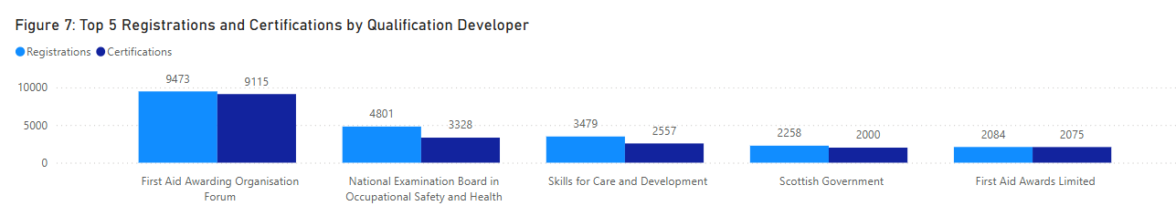
First Aid Awarding Organisation Forum (FAAOF) has the highest number of registrations (24.48%) and certifications (32.33%).

2.5.1 SVQs
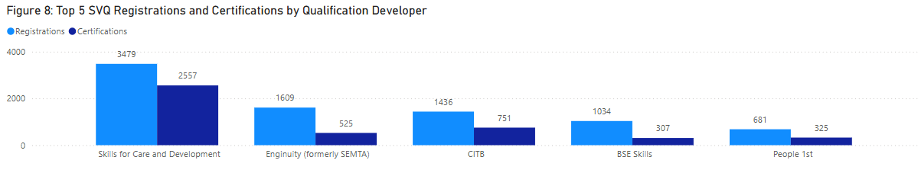
Skills for Care and Development accounts for the largest proportion of SVQ registrations and certifications — 29.21% and 37.59%, respectively.

2.5.2 Non-SVQs
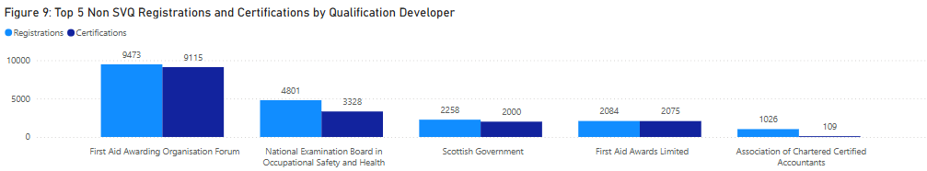
For Non-SVQ qualifications, First Aid Awarding Organisation Forum (FAAOF) has the highest number of registrations (35.36%) and certifications (42.74%).

2.6 Analysis by qualification categories
SQA Accreditation assigns qualifications to one of the following 16 qualification categories:
- 001 Land-based and Aquaculture
- 002 Business Administration
- 003 Health care, Social care and Childcare
- 004 Protective Services
- 005 Catering, Hospitality and Tourism
- 006 Construction
- 007 Creative and Design
- 008 IT and Digital
- 009 Education and Training
- 010 Engineering and Manufacturing
- 011 Hair and Beauty
- 012 Science and Mathematics
- 013 Retail
- 014 Legal and Financial
- 015 Sports and Active Leisure
- 016 Transport and Logistics

Table 5: Top 5 SVQ registrations and certifications by category
Qualification category | Registrations | Certifications
003 Health Care, Social Care and Childcare | 3838 | 2872
006 Construction | 3092 | 1648
010 Engineering and Manufacturing | 2315 | 835
005 Catering, Hospitality and Tourism | 721 | 367
002 Business administration | 609 | 353
Total | 10575 | 6075

The area with the highest number of SVQ registrations and certifications is 003 Health Care, Social Care and Childcare.
- 32.23% of registrations
- 42.21% of certifications

Table 6: Top 5 Non-SVQ registrations and certifications by category
Qualification category | Registrations | Certifications
003 Health Care, Social Care and Childcare | 13144 | 12651
004 Protective Services | 8484 | 6472
010 Engineering and Manufacturing | 1634 | 384
014 Legal and Financial | 1190 | 236
015 Sports and Active Leisure | 752 | 729
Total | 25204 | 20472

The area with the highest number of Non-SVQ registrations and certifications is 003 Health Care, Social Care and Childcare.
- 49.03% of registrations
- 59.31% of certifications

3 Workplace Core Skills
Workplace Core Skills are the broad, transferable skills that help to develop the main capabilities people need to be full, active and responsible members of society. Workplace Core Skills were specifically developed to assess Core Skills in a work environment. They contribute to employability and are a component of Modern Apprenticeships in Scotland. Each Workplace Core Skill is available at SCQF levels 3 to 6.
The five Workplace Core Skills are:
- Communication
- Information and Communication Technology (ICT)
- Numeracy
- Problem Solving
- Working with Others
At the end of Q3 2024–25, there were:
- 95 live accredited Workplace Core Skills
- 9,754 registrations (an increase of 40.06% compared to Q2)
- 6,475 certifications (a decrease of 0.48% compared to Q2)

Workplace Core Skills were offered by five awarding bodies.
Table 7: Workplace core skills registrations and certifications by awarding body
Awarding body | Registrations | Certifications
Scottish Qualifications Authority (SQA) | 7636 | 5772
Institute of the Motor Industry (IMI) | 1832 | 412
City & Guilds | 0 | 83
Excellence, Achievement & Learning Ltd (EAL) | 273 | 176
Vocational Training Charitable Trust (VTCT) | 13 | 32
Total | 9754 | 6475

*City & Guilds registers candidates for Workplace Core Skills on a one-to-many basis using their internal Programme of Study number (PoS), therefore it is not possible at this time to generate registration figures for each Core Skill.
SQA continues to have the highest registrations and certifications for Workplace Core Skills:
- 78.43% of registrations
- 89.14% of certifications

Version Number | Revision Date | Summary of Changes | Author
2 | April 2025 | Non-SVQ figures have been updated, due to revised figures from one of our awarding bodies. This has resulted in all non-SVQ related graphs and tables being updated.  The raw data has also been updated and is published alongside the revised highlights report. | Information and Research Manager

