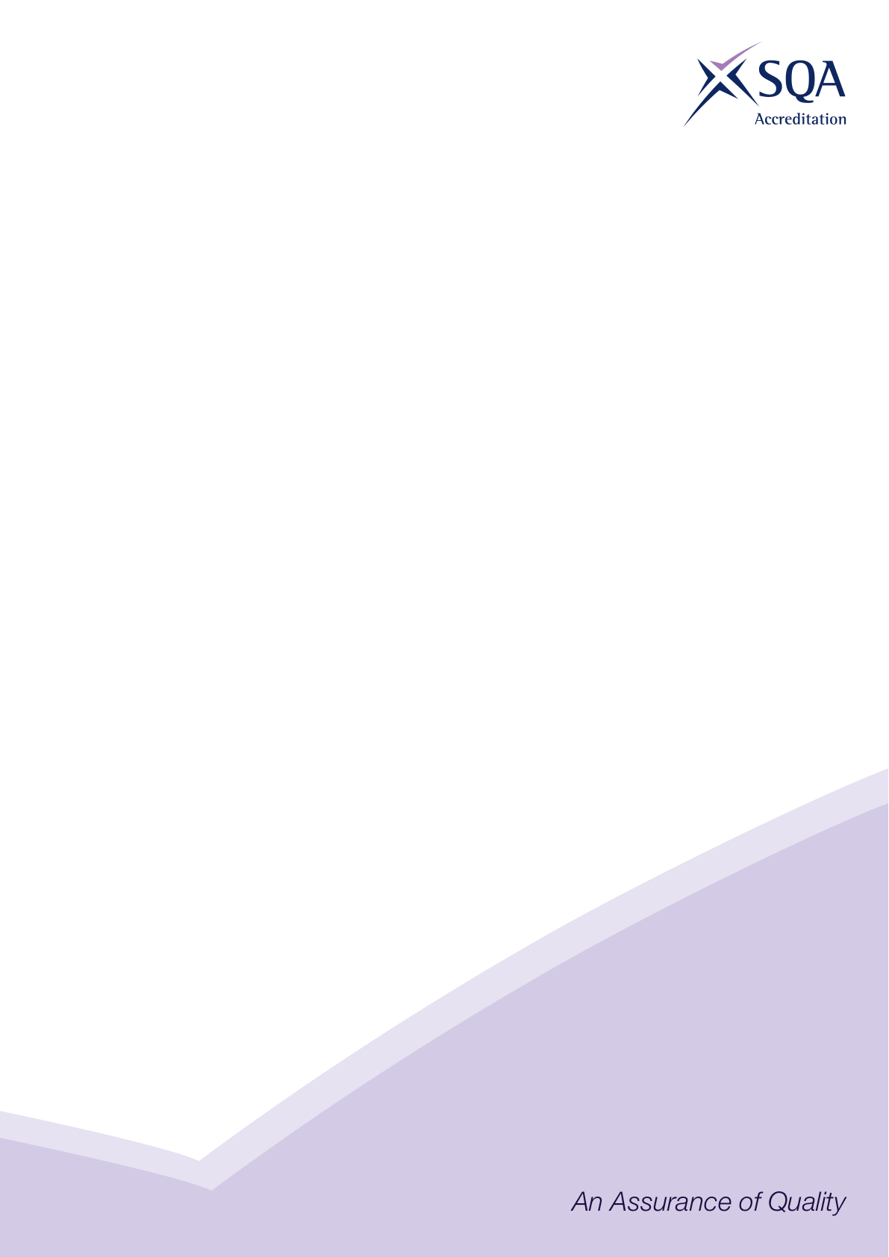
Regulatory Principles Directive
RPDIR — 5

Complaints handling

SQA Accreditation’s requirements for complaints handling are specified within the regulatory principles.
The purpose of this Regulatory Principle Directive is to help awarding bodies to ensure that their complaints-handling processes meet the requirements of the Scottish Public Service Ombudsman (SPSO). The SPSO defines a complaint as “an expression of dissatisfaction by one or more customers about [the college’s] action or lack of action, or about the standard of service provided by [the college] or on its behalf”.
Users of public bodies in Scotland have the right to complain to the SPSO as the final arbiter. Users have to exhaust the public body’s own complaints procedure before the SPSO will consider their complaint, and it must usually have been raised within the previous 12 months. The complaint cannot be under consideration in a court of law.

Requirements
Further education colleges are required to implement a documented complaints process which makes it plain that students can complain, in turn, and once the previous stage has been exhausted, to the centre, to the awarding body, to SQA Accreditation, and to the SPSO. It must explain the circumstances in which each of these can be contacted.
Awarding bodies’ complaints processes for regulated qualifications must make this escalation route clear.
Complaints processes must clearly state the timescale for dealing with the complaint and responding to the complainant. They must indicate that, where an awarding body anticipates that it will exceed its published timescale (eg having to carry out an in-depth investigation) it must advise the complainant of the reasons for any extension. The SPSO expects, that for public bodies, the majority of complaints are handled within five days for frontline resolution, or 20 working days for cases involving investigation. These timescales should be exceeded only in exceptional circumstances and clearly noted.

The SPSO will not consider complaints about academic decisions, such as the outcome of an assessment. These types of complaints should be treated as an appeal and should follow awarding bodies’ appeals processes (which should include reference to SQA Accreditation) as detailed in the SQA Accrediation’s Regulatory Principles.
The SPSO’s Further Education Colleges Model Complaints Handling Procedure can be found at https://www.spso.org.uk/how-to-handle-complaints

26 March 2015

This document is published by SQA Accreditation The Optima Building
For further information, please contact: 58 Robertson Street
SQA Accreditation: accreditation@sqa.org.uk Glasgow, G2 8DQ
SQA Accreditation: www.accreditation.sqa.org.uk/accreditation/Regulation/Regulatory_Requirements
Tel: 0345 213 5249

The SPSO’s rules apply only to public bodies (eg FE colleges and local authority centres). Students at centres that are not public bodies will not be able to escalate their complaints to the SPSO.
For some complaints, there will be no requirement for the college to escalate the complaint to awarding bodies, eg if the complaint concerns the behaviour of a centre staff member (in this case, once the student has exhausted the college’s complaints process, they would go direct to the SPSO if dissatisfied.)

